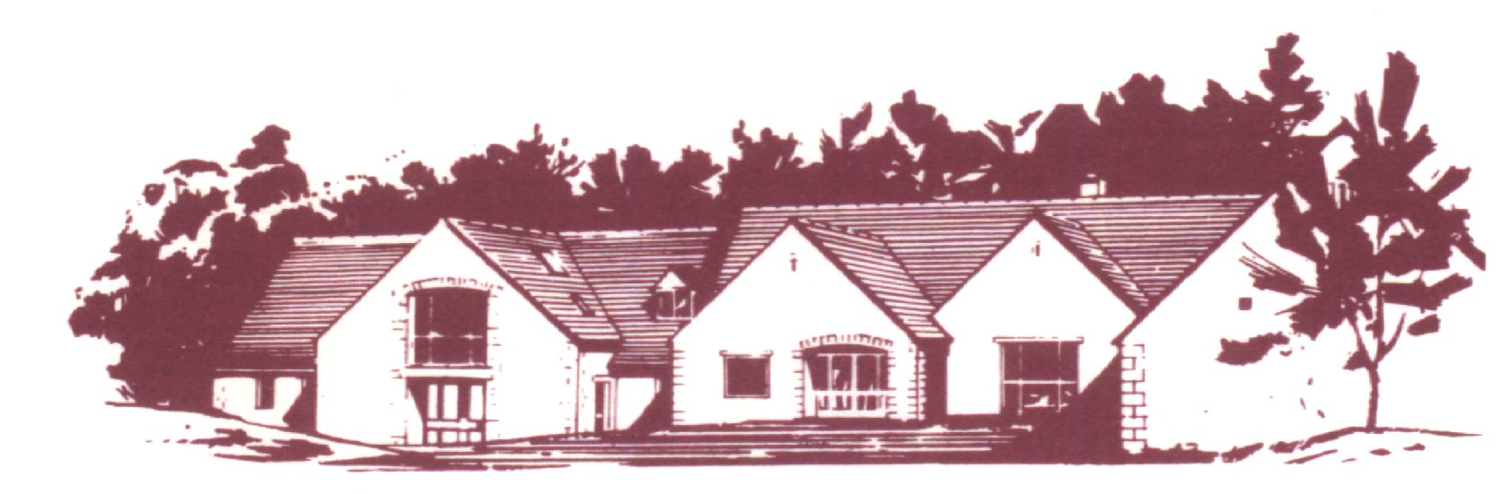

COTSWOLD EDGE GOLF CLUB

SENIORS PAIRS OPEN

Cotswold Edge are again holding their Seniors over 55’s Open
as a Pairs Better Ball Stableford Competition
Prizes for 5 leading pairs
Nearest the pin prizes, 2’s & Charity Raffle

ENTRY £25.00 per pair
Entries to be accompanied by a cheque made payable to
Cotswold Edge Golf Club
Please include your CDH number
and email address (for entry confirmation)

Pair | Name | Club | CDH No | H’Cap
1
2
3

Preferred Tee Times ………………………………..
If you would like to pre-order food please indicate the quantity required from the choices below - £6 each

Ham, egg & chips

Chicken curry & rice &/or chips

Scampi & chips

Contact Name ………………………………………

Email ………………………………………………..

Tel No ………………………………………………

Please send your Entry form with an SAE to

Cotswold Edge Golf Club
Upper Rushmire
Wotton-under-Edge
Glos GL12 7PT

Tel: 01453 844 167 Email: cotswoldedge@freenetname.co.uk

I am happy to be contacted in the future regarding the Senior Pairs Open

