Food will be available on the day

Prize ceremony will take place as soon as possible after the end of play, estimated about 6 pm.

RAFA Dursley and S Glos is part of an organisation of 76,000 members and 500 branches committed to helping any currently serving or retired person who desperately needs support.

With most WW2 and Korea veterans in their 80s and 90s, there is a great deal to do and not forgetting those of more recent conflicts.

Our grateful thanks for all the help you give us in raising money for this worthy cause

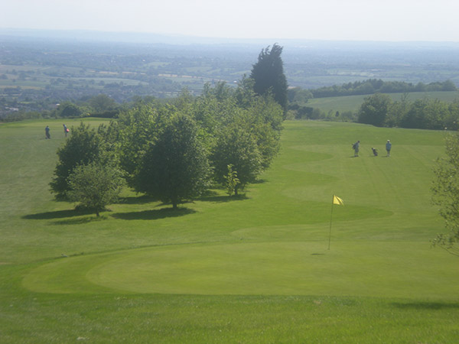

The RAFA Dursley and S Glos Branch would like to thank the Management & Staff at Cotswold Edge Golf Club for their kindness in permitting us to use their course.

RAFA ASSOCIATION CHARITY DAY

by courtesy of
Cotswold Edge Golf Club

The charity day tee times will start at approx 8.30 am, and will be allocated as near as possible to the tee time you request.

Open to teams of four people, the competition will be Stableford format, full handicap, with two scores to count on each hole. It is open to teams of men, ladies or mixed groups. Handicap limits; men 24 and ladies 30.

Price per team is £60.00

We are also running a free men’s singles Stableford competition for the President’s/Chairman’s Cups
and a ladies prize

COTSWOLD EDGE GOLF CLUB

TEAM NAME ……………………………………………………

PLAYER 1 NAME ……………………………………………..

ADDRESS ……………………………………………………….

………………………………………………………………………

………………………………………………………………………

TEL NO ………………………………………………………….

EMAIL ……………………………………………………………

HOME CLUB …………………………………………………..

HANDICAP …………………………………………………….

REQUESTED TEE TIME …………………………………..

HANDICAP CERTIFICATES REQUIRED

ENTRY FEE - £60.00 per team

Please make cheques payable to: RAFA DURSLEY AND
SOUTH GLOS

And send to: Pat Eagle, c/o Cotswold Edge Golf Club

Upper Rushmire, Wotton-under-Edge GL12 7PT

Together with a stamped addressed envelope for
Tee Times

Enquiries: Pat Eagle 01453 890 516

PLAYER 2 ……………………………………………………

HOME CLUB ………………………………………………..

HANDICAP ………………………………………………….

PLAYER 3 …………………………………………………..

HOME CLUB ……………………………………………….

HANDICAP …………………………………………………

PLAYER 4 …………………………………………………..

HOME CLUB ……………………………………………….

HANDICAP …………………………………………………

If you would like to pre-order food please indicate the quantity required from the choices below - £6 each
(pay on the day)

Ham, egg & chips

Chicken curry & rice &/or chips

Scampi & chips

I am happy to be contacted in the future regarding the RAFA Charity Day

