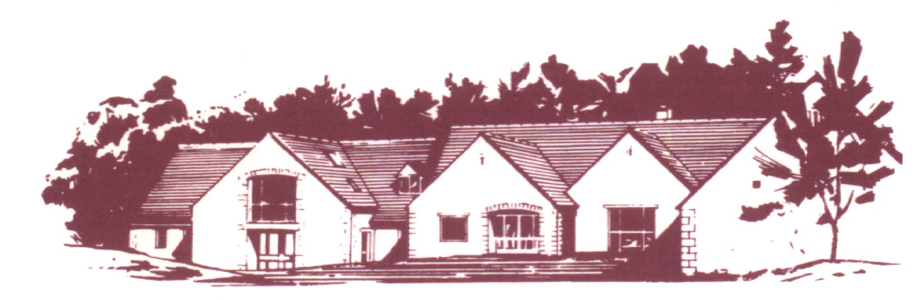

COTSWOLD EDGE GOLF CLUB

THE ANNUAL VINTAGE OPEN

FORMAT: 18 Holes Stableford – Yellow Tees
Handicap: Full Handicap Allowance
Age Limit: 70 and Over On The Day
Prizes: Members 1st, 2nd, 3rd, 4th
Visitors 1st, 2nd, 3rd, 4th, 5th
Nearest the Pin
Raffle

Entry: £12.00 – includes 2’s and on course refreshments.
Entries to be accompanied by a cheque made
payable to “Cotswold Edge Golf Club”.
You may also pay online to:
Account Name:- CEGC Senior Section,
Sort Code 30-98-29, Account Number:- 02664355
Please quote your name as reference followed by “Sen P Open”
and enclose confirmation of payment with your entry
Please ensure CDH numbers are included below.

Please Print Details (including CDH No.)

Name | Club | CDH No | D.O.B. | H’Cap
If you would like to pre-order food please indicate the quantity required from the choices below - £6 each (pay on the day)

Ham, egg & chips

Chicken curry & rice &/or chips

Scampi & chips
Preferred Tee Times ………………………………..

Contact Name ………………………………………

Email ………………………………………………..

Tel No ………………………………………………

Please send your Entry form with an SAE to
Cotswold Edge Golf Club
Upper Rushmire
Wotton-under-Edge Glos GL12 7PT
Tel: 01453 844 167 Email: cotswoldedge@freenetname.co.uk

I am happy to be contacted in the future regarding the Senior Pairs Open

