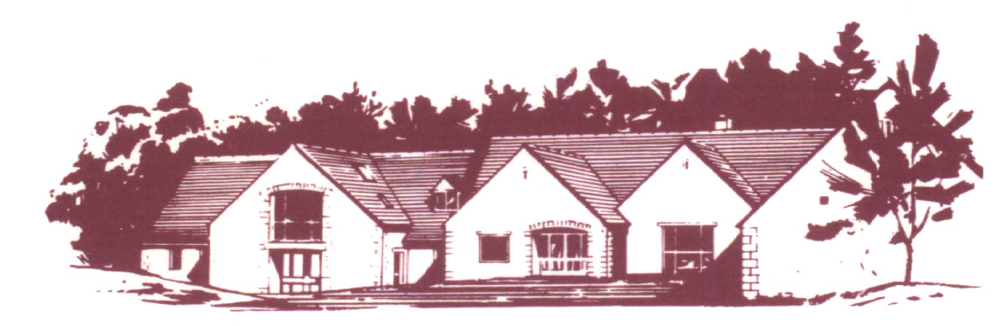
COTSWOLD EDGE GOLF CLUB
LADIES OPEN
BOWMAKER
Best Visitors Prizes

Full Handicap Index (to max 36) CDH Nos required
Members £8 Visitors £15 Play will be in threes

Name ……………………………….. Name ……………………………….
Address …………………………….. Golf Club …………………………..
……………………………………… Handicap …………………………...
……………………………………… CDH Number*……………………
………………………………………
Postcode …………………………….
Golf Club …………………………... Name ………………………………
Tel ………………………………….. Golf Club ………………………….
Email ……………………………….. Handicap …………………………..
Handicap ……………………………. CDH Number*………………….....
CDH Number *………………………
*CDH number is essential so please include it with your details

Preferred Start Time (9 am to 2 pm) ……………….. am …………………. pm
If you would like to eat after your round please pre-order by indicating the quantity required from the choices below - £6.50 each (pay on the day)

Ham, egg & chips

Chicken curry & rice &/or chips

Scampi & chips
Fees .….. @ £8 .….. @ £15 Total £ ……

Please enclose a cheque payable to
Cotswold Edge Golf Club Ladies Section
and a stamped addressed envelope to:
Ladies Open Organiser, Cotswold Edge Golf,
Upper Rushmire, Wotton-under-Edge
Glos GL12 7PT
Tel: 01453 844 167
cotswoldedge@freenetname.co.uk

I am happy to be contacted in the future regarding the Ladies Open

