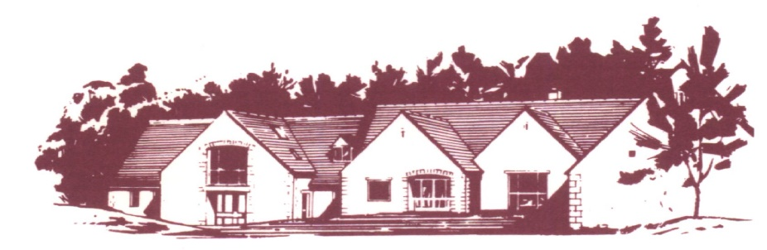

## COTSWOLD EDGE GOLF CLUB

# THE ANNUAL VINTAGE PAIRS OPEN

***Cotswold Edge are again holding their Vintage Over 70’s Open. This year the format is changing to be a better ball Stableford format so please enter as a pair***

Format: Pairs Better Ball Stableford Competition – Yellow Tees

Handicap: 85% Course Handicap Index Allowance

Age Limit: 70 and Over On The Day

Prizes: Members 1st, 2nd, 3rd, 4th

Visitors 1st, 2nd, 3rd, 4th, 5th

Nearest the Pin

Raffle

Entry: **£28.00 per pair**

Entries to be accompanied by a cheque made payable to “Cotswold Edge Golf Club”.

You may also pay online to: Account Name:- CEGC Senior Section,

Sort Code 30-98-29, Account Number:- 02664355

Please quote your name as reference followed by “Ann V Open”

and enclose confirmation of payment with your entry

Please include your CDH numbers and email address (for entry confirmation)

|  |  |  |  |  |
| --- | --- | --- | --- | --- |
| Pair | Name | Club | CDH No | H’Cap Index |
| 1 |  |  |  |  |
|  |  |  |  |  |
| 2 |  |  |  |  |
|  |  |  |  |  |

Preferred Tee Times ………………………………..

If you would like to eat after your round please pre-order by indicating the quantity required from the choices below - £7.00 each (pay on the day)

 Ham, egg & chips

 Chicken curry & rice &/or chips

 Scampi & chips

Contact Name ………………………………………

Email ………………………………………………..

Tel No ………………………………………………

Please send your Entry form with an SAE to

Cotswold Edge Golf Club

Upper Rushmire

Wotton-under-Edge Glos GL12 7PT

Tel: 01453 844 167

Email: [cotswoldedge@freenetname.co.uk](mailto:cotswoldedge@freenetname.co.uk)

Please tick the box if you are happy to be contacted in future for the Annual Vintage Open

I am happy to be contacted in the future regarding the Vintage Pairs Open