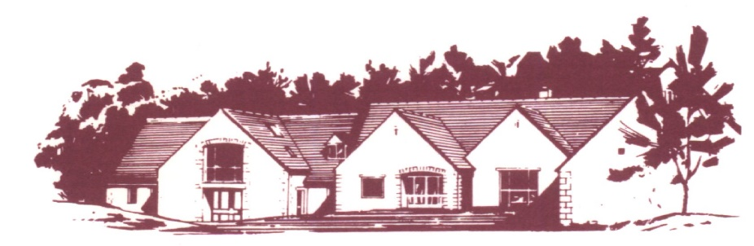

**COTSWOLD EDGE GOLF CLUB**

**LADIES OPEN**

**BOWMAKER**

**Best Visitors Prizes**

# **Full Course Handicap (to max 40/HI 36.3) CDH Nos required**

**Members £8 Visitors £15 Play will be in threes**

**Name ……………………………….. Name ……………………………….**

**Address …………………………….. Golf Club …………………………..**

**……………………………………… Handicap …………………………...**

**……………………………………… CDH Number*……………………**

**………………………………………**

**Postcode …………………………….**

**Golf Club …………………………... Name ………………………………**

**Tel ………………………………….. Golf Club ………………………….**

**Email ……………………………….. Handicap …………………………..**

**Handicap ……………………………. CDH Number*………………….....**

**CDH Number *………………………**

**\*CDH number is essential so please include it with your details**

Preferred Start Time (9.30 am to 12.30 pm) ……………….. am …………………. pm

If you would like to eat after your round please pre-order by indicating the quantity required from the choices below - £7.00 each (pay on the day)

 Ham, egg & chips

 Chicken curry & rice &/or chips

 Scampi & chips

**Fees .….. @ £8 .….. @ £15 Total £ ……**

**Please enclose a cheque payable to**

**Cotswold Edge Golf Club Ladies Section**

**and a stamped addressed envelope to:**

**Ladies Open Organiser, Cotswold Edge Golf,**

**Upper Rushmire, Wotton-under-Edge**

**Glos GL12 7PT**

**Tel: 01453 844 167**

[**cotswoldedge@freenetname.co.uk**](mailto:cotswoldedge@freenetname.co.uk)

**I am happy to be contacted in the future regarding the Ladies Open**