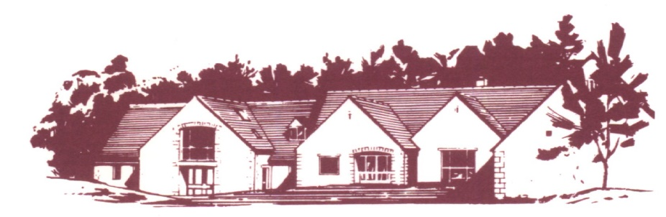

Cotswold Edge Golf Club (Ladies Section)

COFFEE MORNING and

9 HOLE STABLEFORD COMPETITION
Divisional Prizes

Entry Fee £8 per person – play in 3s
Open to Everyone with a WHS Handicap Index

Lunches and sandwiches will be available as well as
usual stalls inc jewellery/bric-a-brac, cakes, plants, tombola, raffle etc

NAME ……………………………………………… TEL …………………………….

ADDRESS ……………………………………………………………………….……………

…………………………………………………..….. POSTCODE ……………………

EMAIL ………………………………………..…… Member (CDH) No & H/I

GOLF CLUB …………………………………..….. …………………………..

PARTNER ………………………………..……….. Member (CDH) No & H/I

GOLF CLUB …………………………………..….. …………………………..

PARTNER ………………………………..……….. Member (CDH) No & H/I

GOLF CLUB …………………………………..….. …………………………..

Preferred start time (8.30 am to 11.30 am) ……………………………….

Fee enclosed (£8 per player) £ ……………………………...

Bar snacks will be available to order on the day subject to availability

Please make cheques payable to Cotswold Edge Golf Club (Ladies Section) and send
the completed formed together with the fee and SAE to:

Ladies Coffee Morning Organiser, Cotswold Edge Golf Club
Upper Rushmire, Wotton-under-Edge Glos GL12 7PT
Tel: 01453 844 167 cotswoldedge@freenetname.co.uk

I am happy to be contacted in the future regarding the Ladies Coffee Morning

