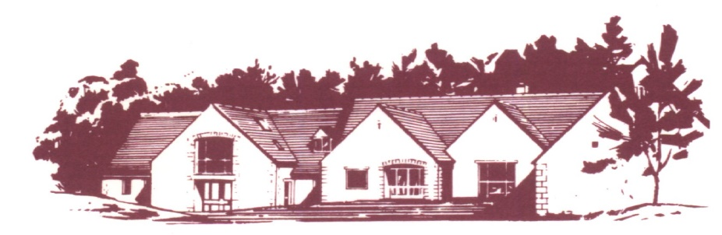

Cotswold Edge Golf Club (Ladies Section)

COFFEE MORNING and

9 HOLE STABLEFORD COMPETITION
Divisional Prizes
Entry Fee £8 per person – play in 3s
Open to Everyone with a WHS Handicap Index
Lunches and sandwiches will be available as well as
usual stalls inc jewellery/bric-a-brac, cakes, plants, tombola, raffle etc

NAME ……………………………………………… TEL …………………………….

ADDRESS ……………………………………………………………………….……………

…………………………………………………..….. POSTCODE ……………………

EMAIL ………………………………………..…… Member (CDH) No & H/I

GOLF CLUB …………………………………..….. …………………………..

PARTNER ………………………………..……….. Member (CDH) No & H/I

GOLF CLUB …………………………………..….. …………………………..

PARTNER ………………………………..……….. Member (CDH) No & H/I

GOLF CLUB …………………………………..….. …………………………..

Preferred start time (8.30 am to 11.30 am) ……………………………….

Fee enclosed (£8 per player) £ ……………………………...

Bar snacks will be available to order on the day subject to availability
Please make cheques payable to Cotswold Edge Golf Club (Ladies Section).
You may also pay online to:
Account Name:- CEGC Ladies Section,
Sort Code 30-98-29, Account Number:- 02664258
Please quote your name as reference followed by “Coffee Morning”
and send the completed formed together with the fee/confirmation of payment to:

Ladies Coffee Morning Organiser, Cotswold Edge Golf Club
Upper Rushmire, Wotton-under-Edge Glos GL12 7PT
Tel: 01453 844 167 cotswoldedgegolfclub@outlook.com

I am happy to be contacted in the future regarding the Ladies Coffee Morning

