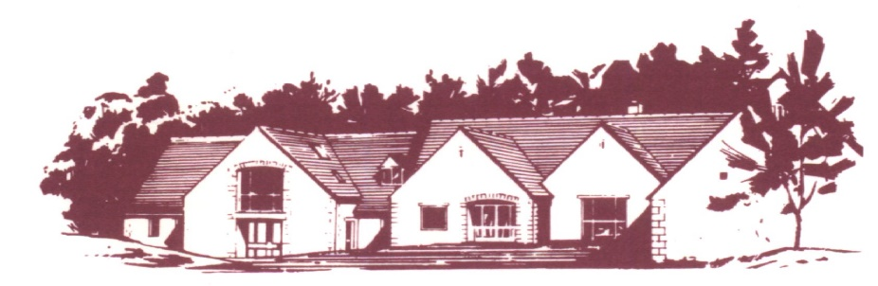

**COTSWOLD EDGE GOLF CLUB**

**LADIES OPEN BOWMAKER**

**Best Visitors Prizes**

# **Full Course Handicap (to max 40/HI 36.3) CDH Nos required**

**Members £8 Visitors £15 Play will be in threes**

**Name ……………………………….. Name ……………………………….**

**Address …………………………….. Golf Club …………………………..**

**……………………………………… Handicap …………………………...**

**……………………………………… CDH Number*……………………**

**………………………………………**

**Postcode …………………………….**

**Golf Club …………………………... Name ………………………………**

**Tel ………………………………….. Golf Club ………………………….**

**Email ……………………………….. Handicap …………………………..**

**Handicap ……………………………. CDH Number*………………….....**

**CDH Number *………………………**

**\*CDH number is essential so please include it with your details**

Preferred Start Time (9.30 am to 12.30 pm) ……………….. am …………………. pm

If you would like to eat after your round please pre-order by indicating the quantity required from the choices below - (pay on the day)

 Ham, egg & chips

 Chicken curry & rice &/or chips

 Scampi & chips

**Fees .….. @ £8 .….. @ £15 Total £ ……**

**Please make cheques payable to**

**Cotswold Edge Golf Club (Ladies Section).**

**You may also pay online to:**

**Account Name:- CEGC Ladies Section,**

**Sort Code 30-98-29, Account Number:- 02664258**

**Please quote your name as reference followed by**

**“Ladies Open” and send the completed formed**

**together with the fee/confirmation of payment to:**

**Ladies Open Organiser, Cotswold Edge Golf,**

**Upper Rushmire, Wotton-under-Edge**

**Glos GL12 7PT Tel: 01453 844 167**

[**cotswoldedgegolfclub@outlook.com**](mailto:cotswoldedgegolfclub@outlook.com)

**I am happy to be contacted in the future regarding the Ladies Open**