

**Food will be available on the day**

**Prize ceremony will take place as soon as possible after the end of play, estimated about 6 pm.**

**RAFA Dursley and S Glos is part of an organisation of 76,000 members and 500 branches committed to helping any currently serving or retired person who desperately needs support.**

**With most WW2 and Korea veterans in their 80s and 90s, there is a great deal to do and not forgetting those of more recent conflicts.**

**Our grateful thanks for all the help you give us in raising money for this worthy cause**

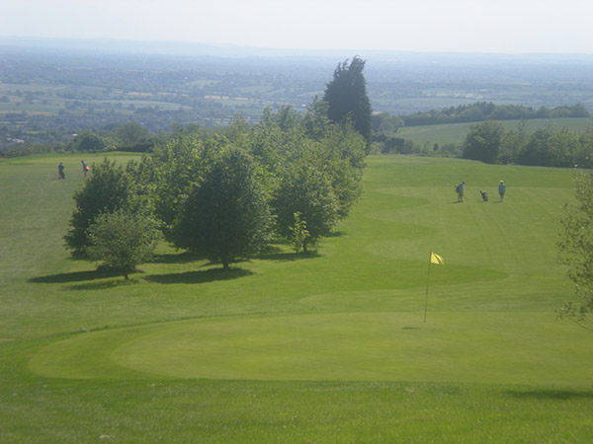

**The RAFA Dursley and S Glos Branch would like to thank the Management & Staff at Cotswold Edge Golf Club for their kindness in permitting us to use their course.**



**RAFA ASSOCIATION CHARITY DAY**

**by courtesy of**

**Cotswold Edge Golf Club**

The charity day tee times will start at approx 8.30 am, and will be allocated as near as possible to the tee time you request.

**Open to teams of four people, the competition will be Stableford format, full handicap, with two scores to count on each hole. It is open to teams of men, ladies or mixed groups. Course Handicap limits; Ladies 40 (HI 36.3) Men 32 (HI 28.6 yellow tees).**

### Price per team is £60.00

We are also running a free men’s singles Stableford competition for the President’s/Chairman’s Cups

and a ladies prize



**COTSWOLD EDGE GOLF CLUB**

# TEAM NAME ……………………………………………………

PLAYER 1 NAME ……………………………………………..

ADDRESS ……………………………………………………….

………………………………………………………………………

………………………………………………………………………

TEL NO ………………………………………………………….

EMAIL ……………………………………………………………

HOME CLUB …………………………………………………..

HANDICAP …………………………………………………….

REQUESTED TEE TIME …………………………………..

HANDICAP CERTIFICATES REQUIRED

ENTRY FEE - £60.00 per team

Please make cheques payable to: RAF Association.

Bank Details for BACS payment:

Sort code: 30-98-29 Account No: 03471372 (please add your name/team name as reference)

## And send to: Pat Eagle, c/o Cotswold Edge Golf Club

Upper Rushmire, Wotton-under-Edge GL12 7PT

Together with a **stamped addressed** envelope for

Tee Times

Enquiries: Pat Eagle 01453 890 516

PLAYER 2 ……………………………………………………

HOME CLUB ………………………………………………..

HANDICAP ………………………………………………….

PLAYER 3 …………………………………………………..

HOME CLUB ……………………………………………….

HANDICAP …………………………………………………

PLAYER 4 …………………………………………………..

HOME CLUB ……………………………………………….

HANDICAP …………………………………………………

If you would like to eat after your round please pre-order by indicating the quantity required from the choices below - (pay on the day)

 Ham, egg & chips

 Chicken curry & rice &/or chips

 Scampi & chips

I am happy to be contacted in the future regarding the RAFA Charity Day