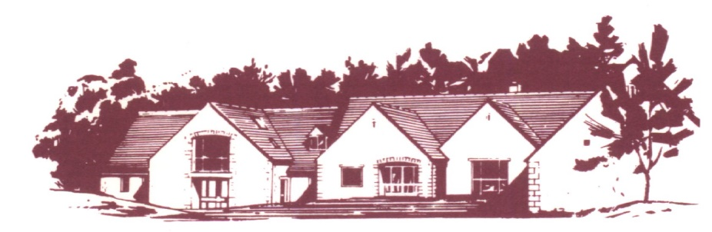

## COTSWOLD EDGE GOLF CLUB

# SENIORS PAIRS OPEN

Cotswold Edge are again holding their Seniors over 55’s Open

as a Pairs Better Ball Stableford Competition

85% Course Handicap Allowance – Yellow Tees

Prizes for 5 leading pairs

Nearest the pin prizes, 2’s & Charity Raffle

ENTRY £36.00 per pair

Entries to be accompanied by a cheque made payable to

“Cotswold Edge Golf Club”. You may also pay online to:

Account Name:- CEGC Senior Section,

Sort Code 30-98-29, Account Number:- 02664355

Please quote your name as reference followed by “Sen P Open”

and enclose confirmation of payment with your entry

Please include your CDH number and email address (for entry confirmation)

|  |  |  |  |  |
| --- | --- | --- | --- | --- |
| Pair | Name | Club | CDH No | H’Cap Index |
| 1 |  |  |  |  |
|  |  |  |  |  |
| 2 |  |  |  |  |
|  |  |  |  |  |
| 3 |  |  |  |  |
|  |  |  |  |  |

Preferred Tee Times ………………………………..

If you would like to eat after your round please pre-order by indicating the quantity required from the choices below - (pay on the day)

 Ham, egg & chips

 Chicken curry & rice &/or chips

 Scampi & chips

Contact Name ………………………………………

Email ………………………………………………..

Tel No ………………………………………………

Please send your Entry form to

Cotswold Edge Golf Club

Upper Rushmire

Wotton-under-Edge

Glos GL12 7PT

Tel: 01453 844 167 Email: [cotswoldedgegolfclub@outlook.com](mailto:cotswoldedgegolfclub@outlook.com)

I am happy to be contacted in the future regarding the Senior Pairs Open