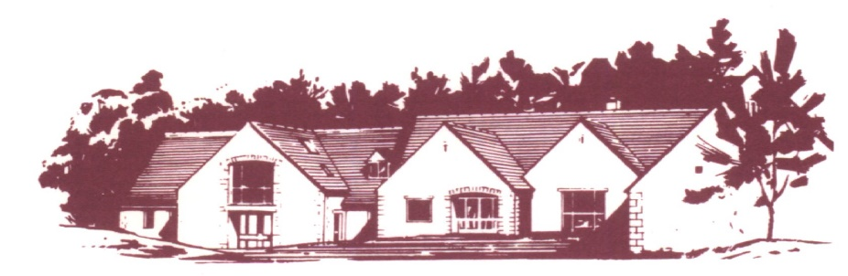

## COTSWOLD EDGE GOLF CLUB

# THE VINTAGE OPEN

Format: Individual Stableford Competition – Yellow Tees

Handicap: 95% Course Handicap Index Allowance

Age Limit: 70 and Over On The Day

Prizes: Members 1st, 2nd, 3rd, 4th

Visitors 1st, 2nd, 3rd, 4th, 5th

Nearest the Pin

2s Competition

Raffle

Entry: **£18.00 per entry**

Entries to be accompanied by a cheque made payable to “Cotswold Edge Golf Club”.

You may also pay online to: Account Name:- CEGC Senior Section,

Sort Code 30-98-29, Account Number:- 02664355

Please quote your name as reference followed by “Vint Open”

and enclose confirmation of payment with your entry

Please include your CDH numbers and email address (for entry confirmation)

|  |  |  |  |
| --- | --- | --- | --- |
| Name | Club | CDH No | H’Cap Index |
|  |  |  |  |
|  |  |  |  |
|  |  |  |  |
|  |  |  |  |

Preferred Tee Time ………………………………..

If you would like to eat after your round please pre-order by indicating the quantity required from the choices below - (pay on the day)

 Ham, egg & chips

 Chicken curry & rice &/or chips

 Scampi & chips

Contact Name ………………………………………

Email ………………………………………………..

Tel No ………………………………………………

Please send your Entry form to

Cotswold Edge Golf Club

Upper Rushmire

Wotton-under-Edge Glos GL12 7PT

Tel: 01453 844 167

Email: [cotswoldedgegolfclub@outlook.com](mailto:cotswoldedge@freenetname.co.uk)

Please tick the box if you are happy to be contacted in future for the Vintage Open

I am happy to be contacted in the future regarding the Vintage Open