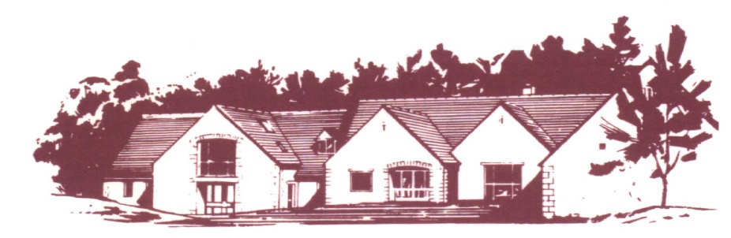
COTSWOLD EDGE GOLF CLUB
LADIES OPEN BOWMAKER
Best Visitors Prizes

Full Course Handicap (to max 40/HI 36.3) CDH Nos required
Members £10 Visitors £20 Play will be in threes
Halfway House – Refreshments & Drinks available
Name ……………………………….. Name ……………………………….
Address …………………………….. Golf Club …………………………..
……………………………………… Handicap …………………………...
……………………………………… CDH Number*……………………
………………………………………
Postcode …………………………….
Golf Club …………………………... Name ………………………………
Tel ………………………………….. Golf Club ………………………….
Email ……………………………….. Handicap …………………………..
Handicap ……………………………. CDH Number*………………….....
CDH Number *………………………
*CDH number is essential so please include it with your details
Preferred Start Time (9.30 am to 12.30 pm) ……………….. am …………………. pm
Fees .….. @ £10 .….. @ £20 Total £ ……
If you would like to eat after your round, please pre-order by indicating the quantity required from the choices below (pay on the day)

Ham, egg & chips

Chicken curry & rice &/or chips

Scampi & chips

Preferred Payment By Bank Transfer.
Account Name:- CEGC Ladies Section,
Sort Code 30-98-29, Account Number:- 02664258
Please quote your name as reference followed by
“Ladies Open” and send the completed form
together with confirmation of payment to:
Ladies Open Organiser, Cotswold Edge Golf,
Upper Rushmire, Wotton-under-Edge
Glos GL12 7PT Tel: 01453 844 167
Or email: cotswoldedgegolfclub@outlook.com

I am happy to be contacted in the future regarding the Ladies Open

