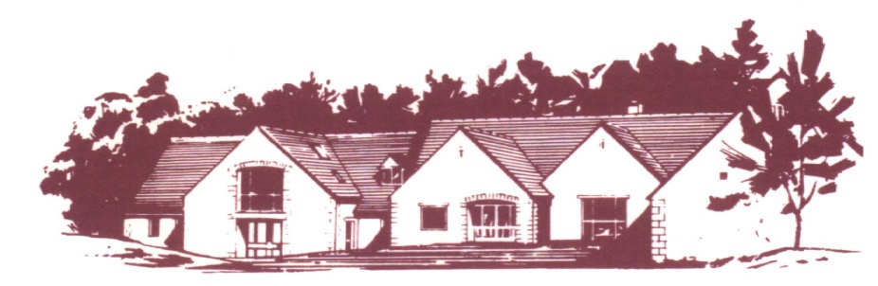

COTSWOLD EDGE GOLF CLUB

SENIORS PAIRS OPEN – VISITING PLAYERS

Format: Pairs Better Ball Stableford Competition – This is a Non-Qualifying Competition
Handicap: 85% Course Handicap Index Allowance, YELLOW tees
Age Limit: 55 and Over On The Day
Prizes: Members 1st, 2nd, 3rd, 4th
Visitors 1st, 2nd, 3rd, 4th, 5th
Nearest the Pin and 2’s Competition prizes and Raffle for the Club Charity

VISITOR ENTRY £40.00 per team (2 Players)
Entries to be accompanied by a cheque made payable to “Cotswold Edge Golf Club”.
You may also pay online to:
Account Name:- CEGC Senior Section, Sort Code 30-98-29, Account Number:- 02664355
Please quote your name as reference followed by “Sen P Open” and enclose confirmation of
payment with your entry, your CDH numbers and email address (for entry confirmation).

To be eligible for prizes, players must have at least 3 18-hole qualifying scores from
qualifying Competitions on their England Golf record in the 12 months prior to the date of this competition.
 | Name | Club | CDH No | H’Cap Index
1
2

Preferred Tee Time ………………………………..
If you would like to eat after your round, please pre-order by indicating the quantity required from the choices below - pay on the day.

Ham, egg & chips

Chicken curry & rice &/or chips

Scampi & chips

Contact Name ………………………………………

Email ………………………………………………..

Tel No ………………………………………………

Please send your Entry form to
Cotswold Edge Golf Club
Upper Rushmire
Wotton-under-Edge Glos GL12 7PT
Tel: 01453 844 167
Email: cotswoldedgegolfclub@outlook.com

($√)$I am happy to be contacted in the future regarding the Seniors Pairs Open
* Cancellations must be received at least 7 days prior to the event. After this date refunds will only be made if the vacancy can be re-filled.

